Assignment 1

# Task 1

## HTML Task

1. Adding square shaped list items for an unordered list.

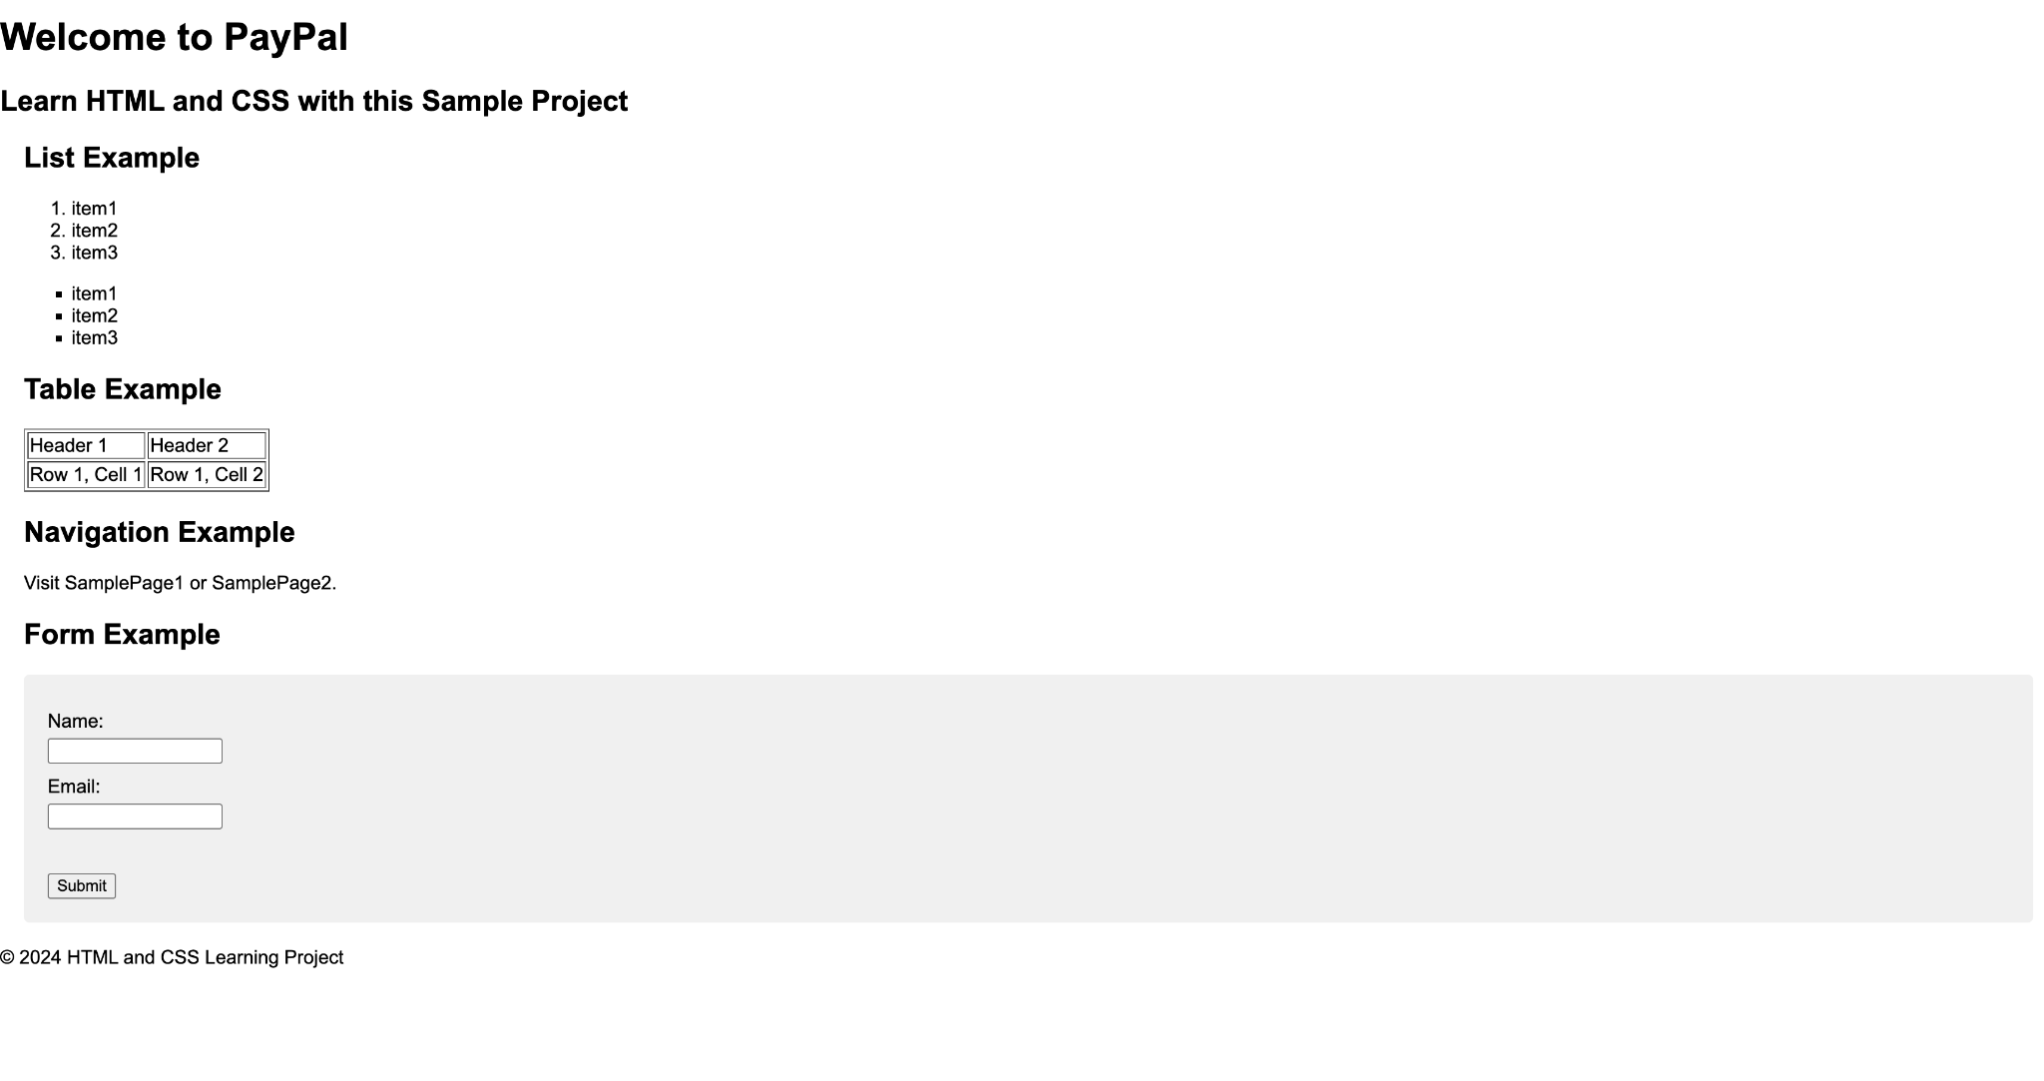

1. This row spans across 2 columns in the table.

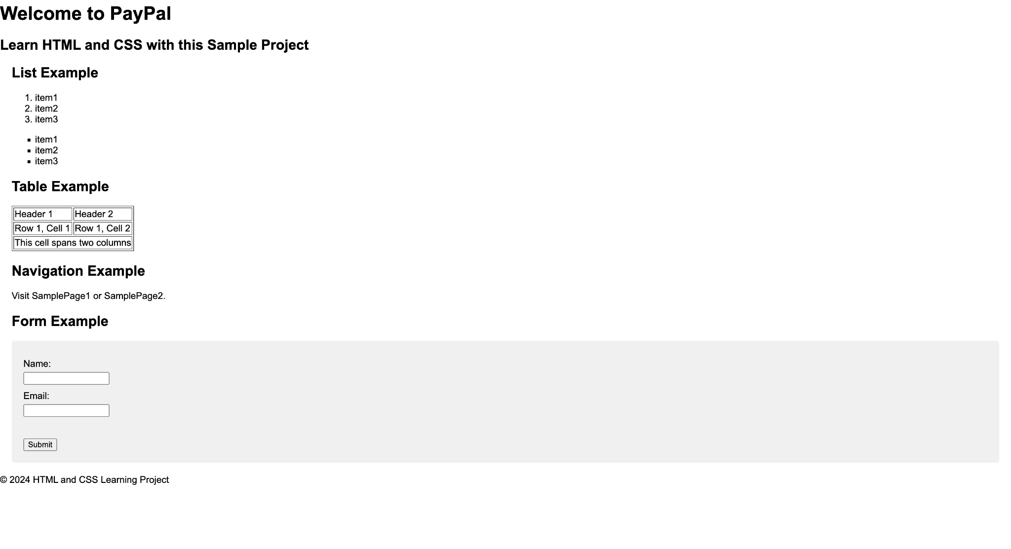

1. Sample page links added as hypertext.

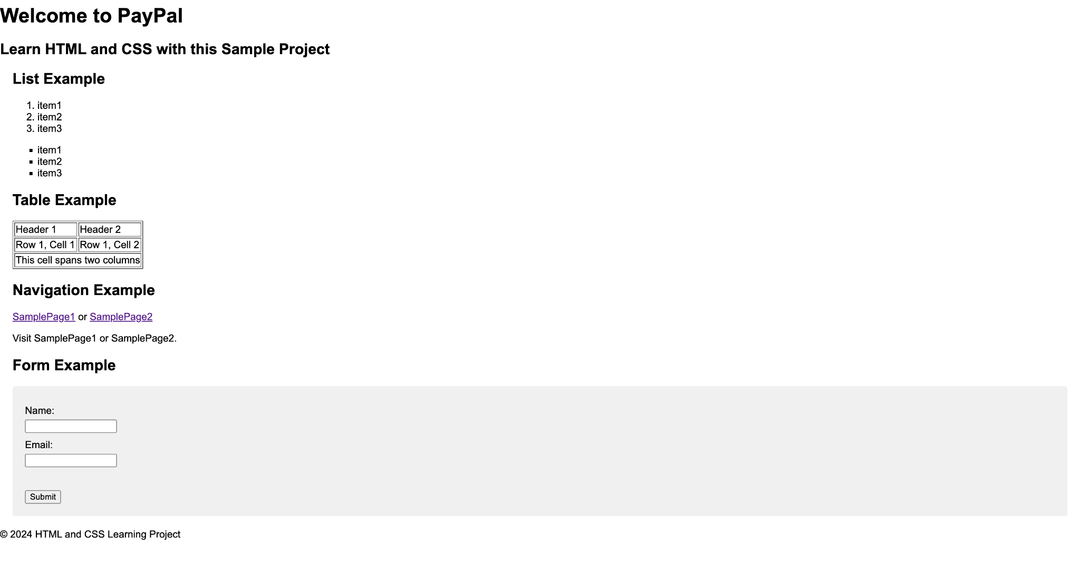

1. Adding phone number field

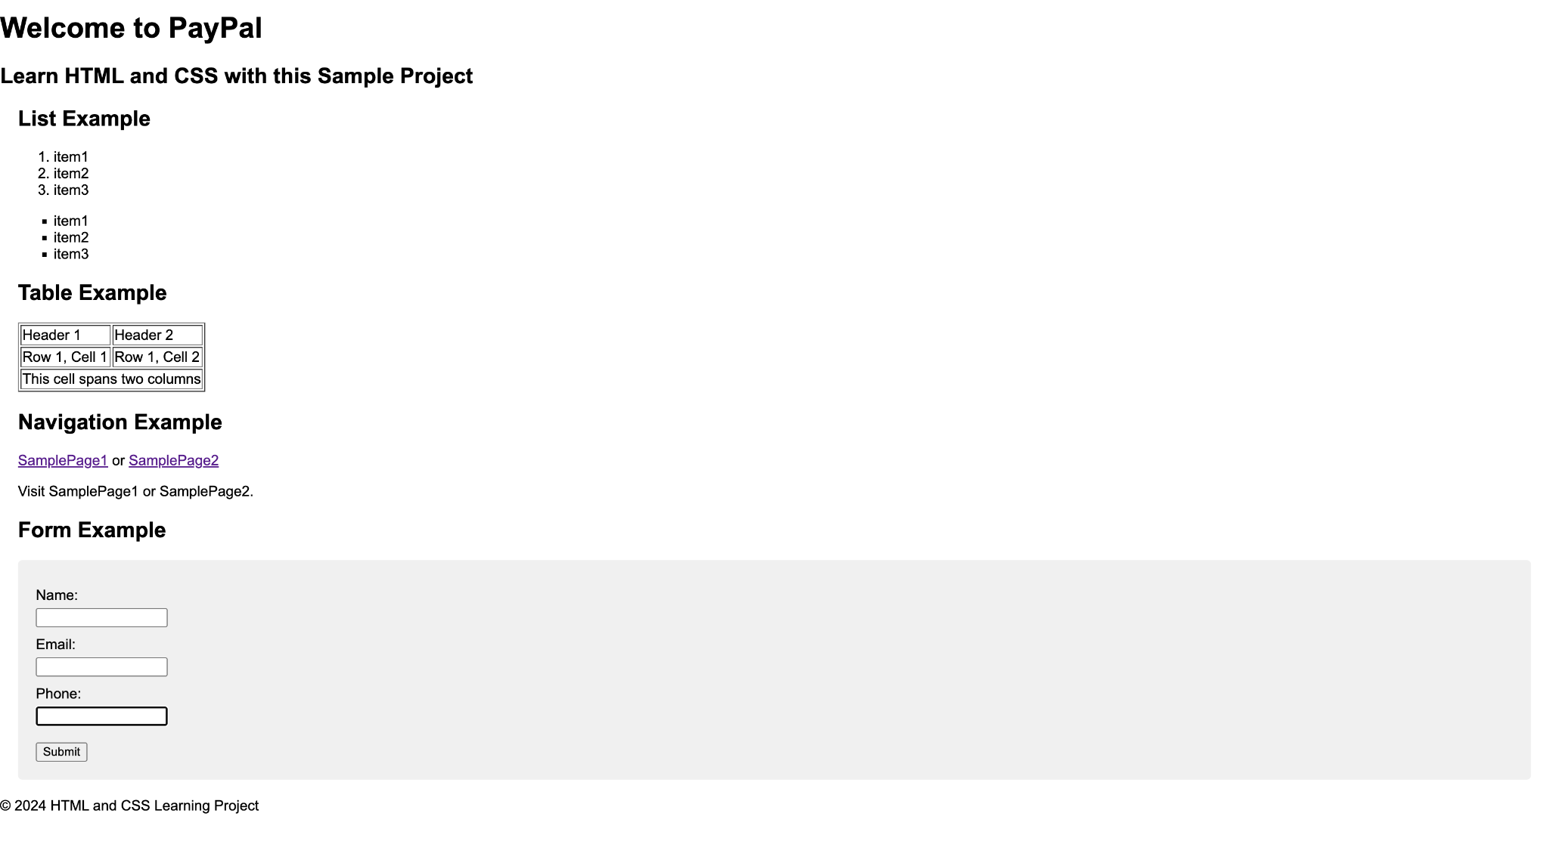

## CSS task

1. Header styles

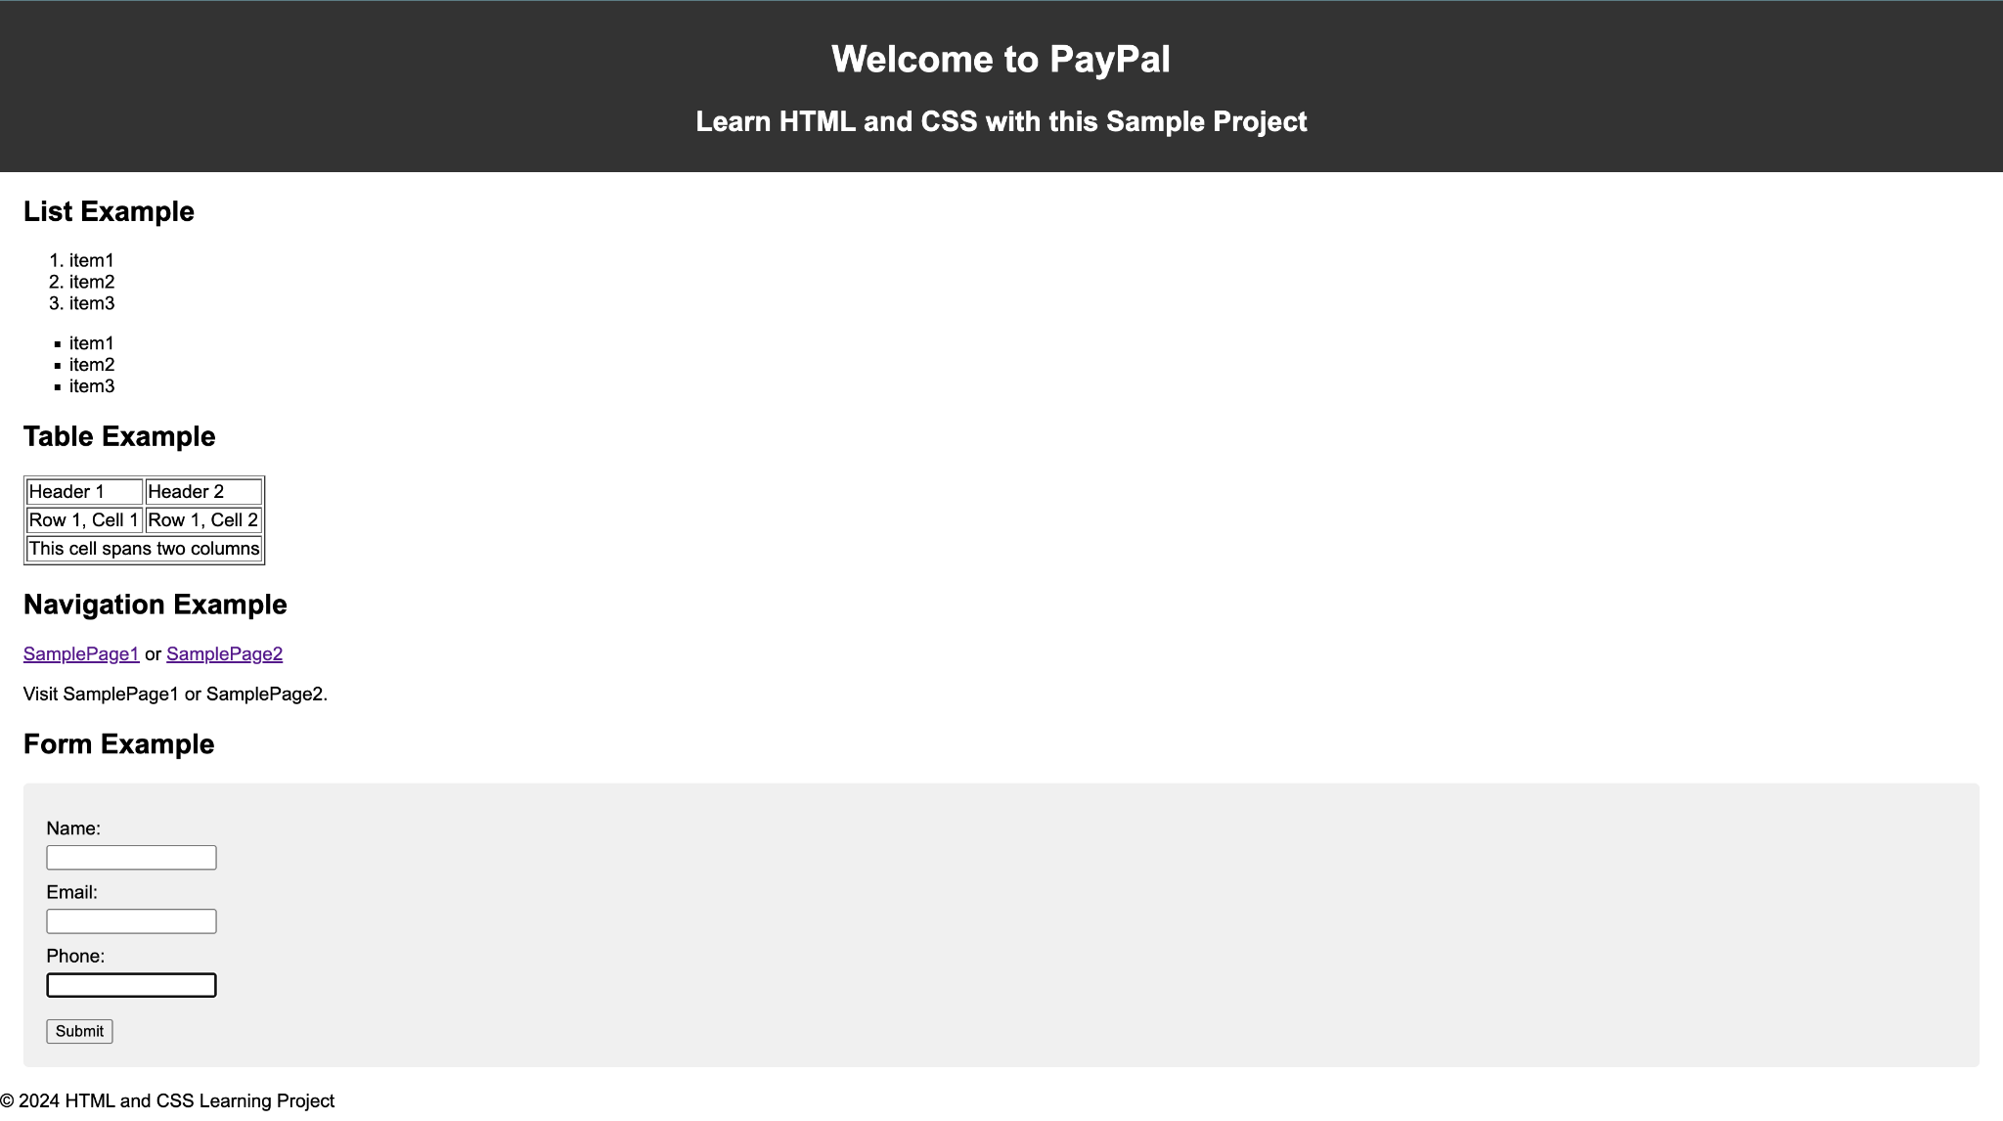

1. Main padding 20 px

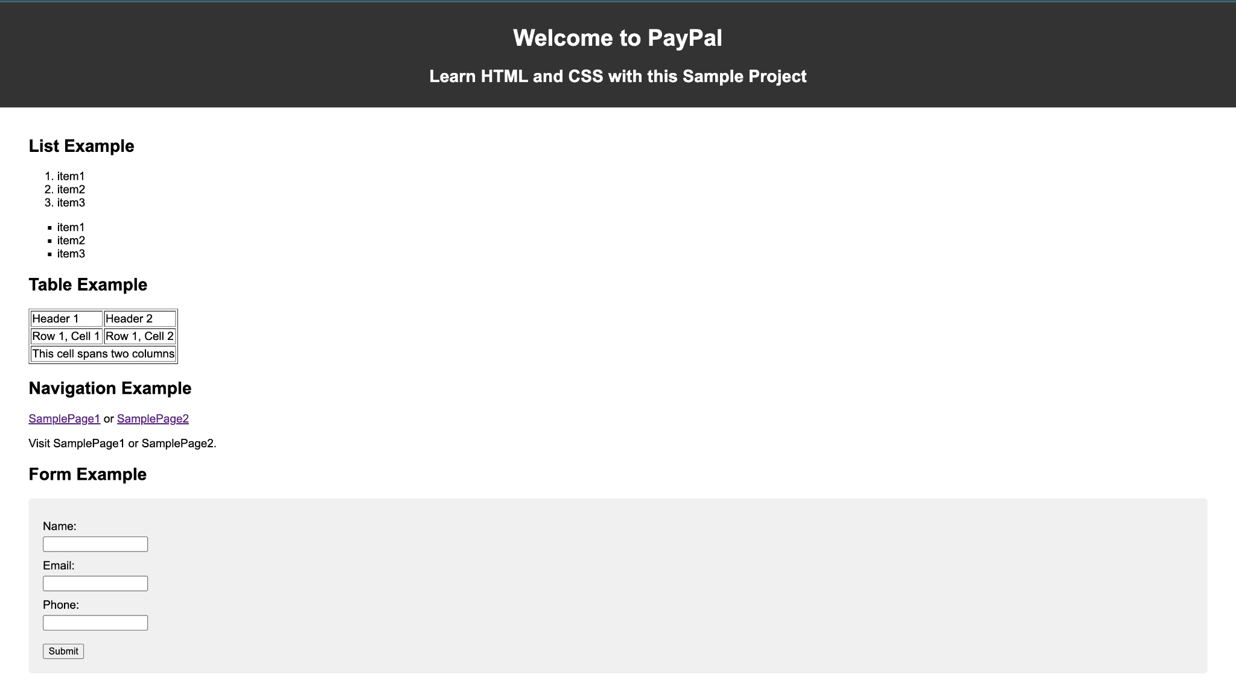

1. Adding style to input fields in forms

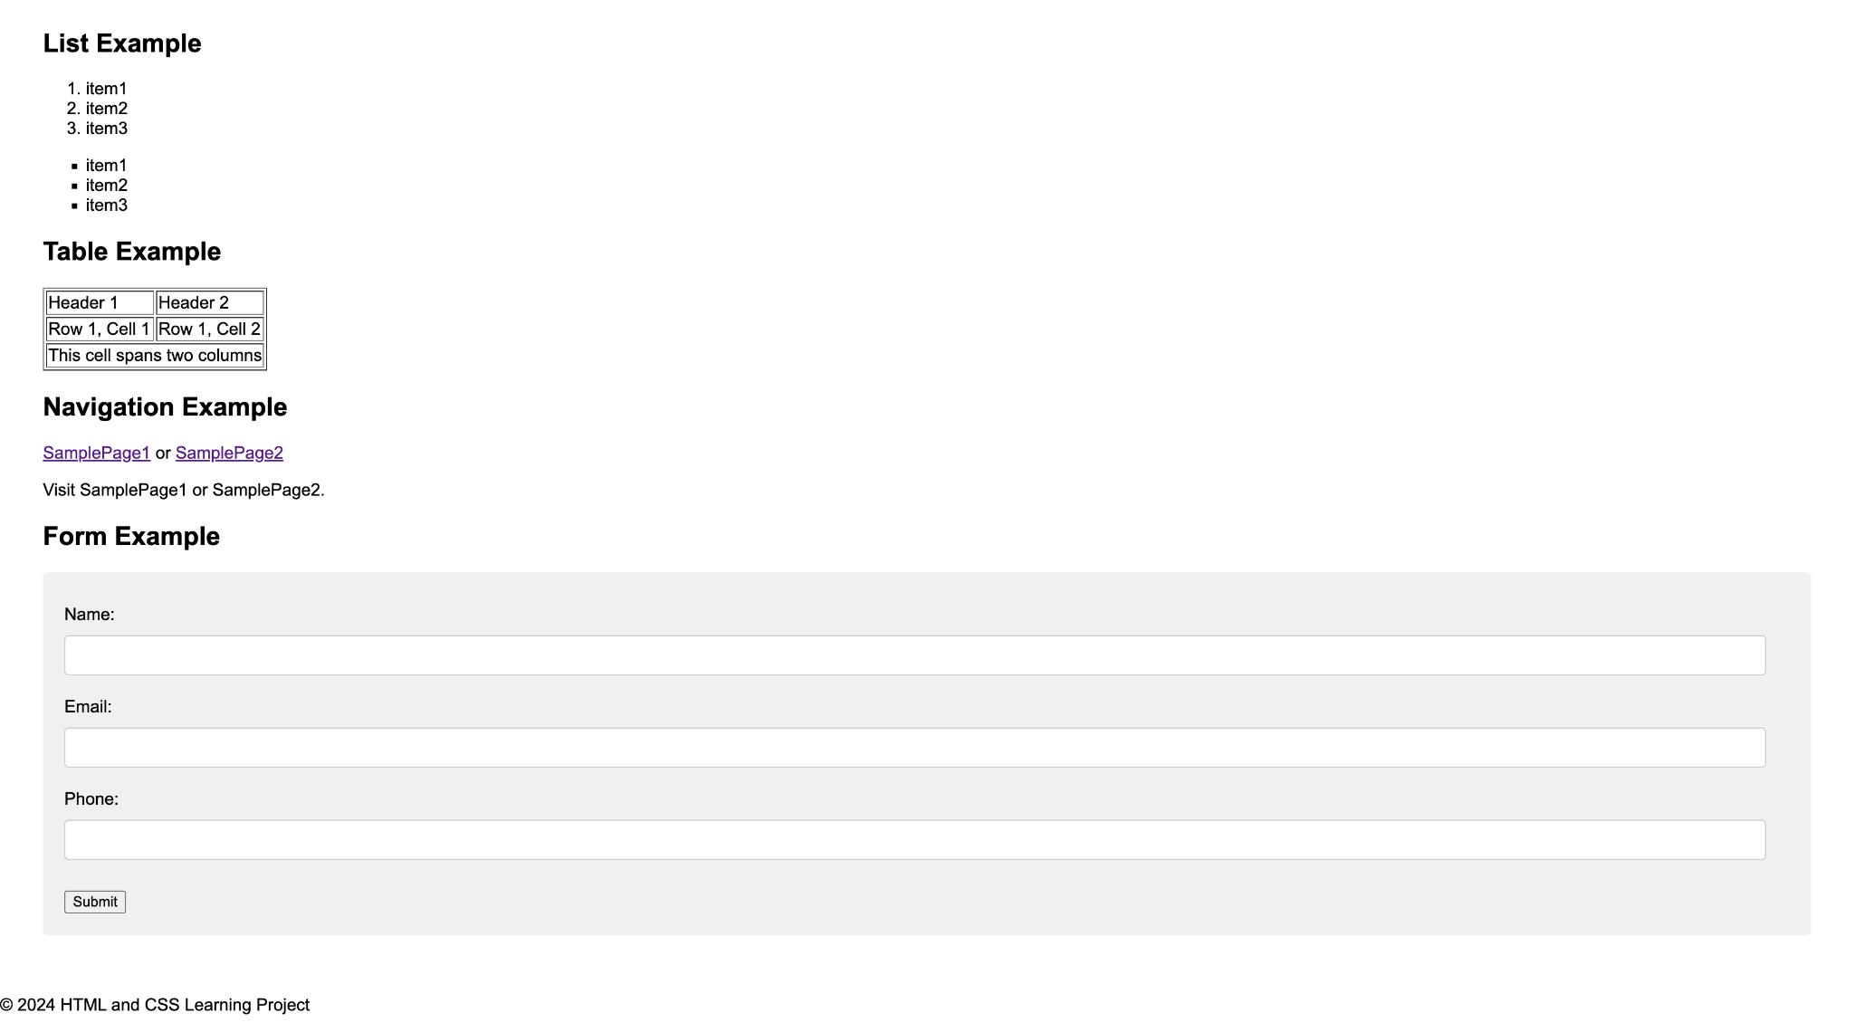

1. Footer fixed with styles at bottom

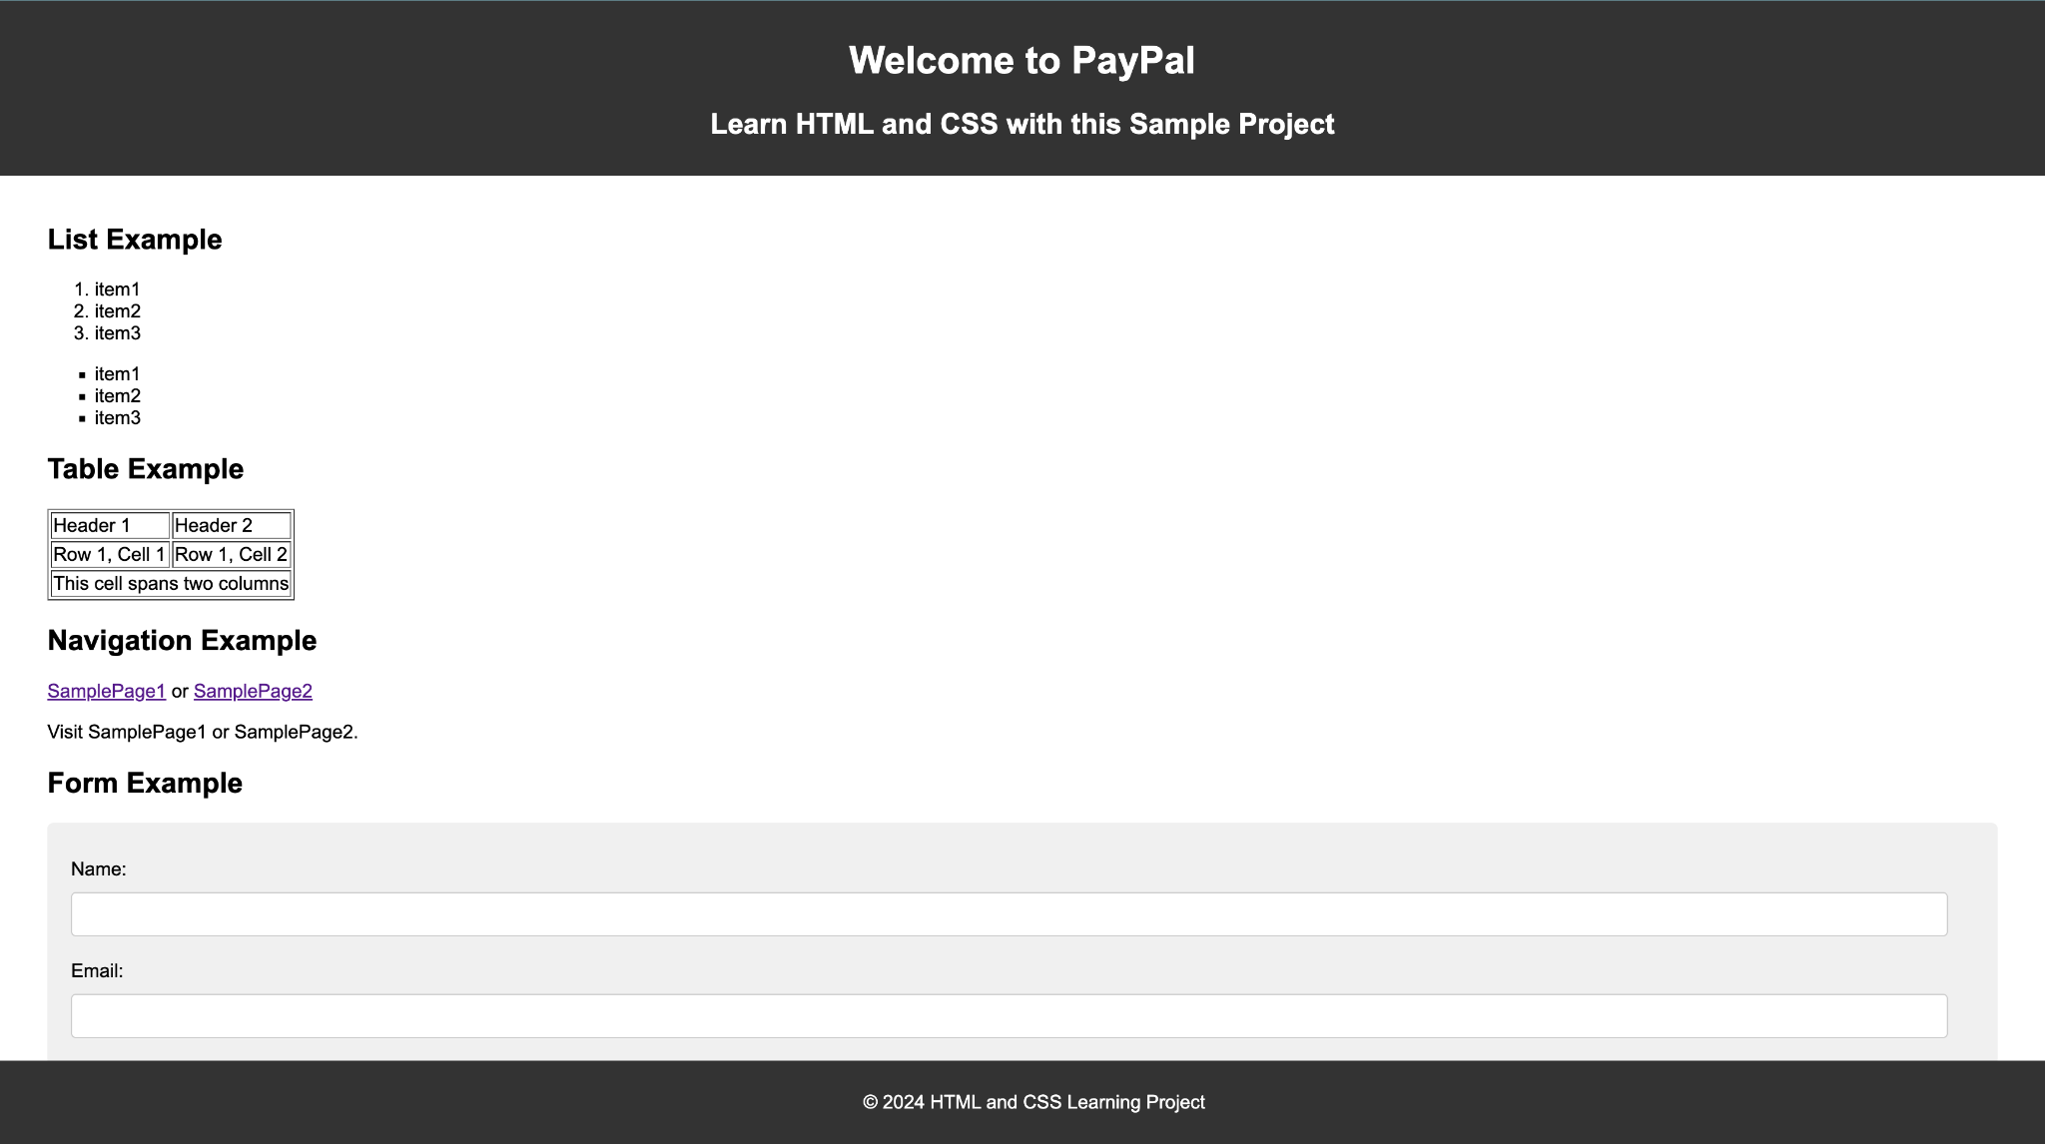

Enhanced task

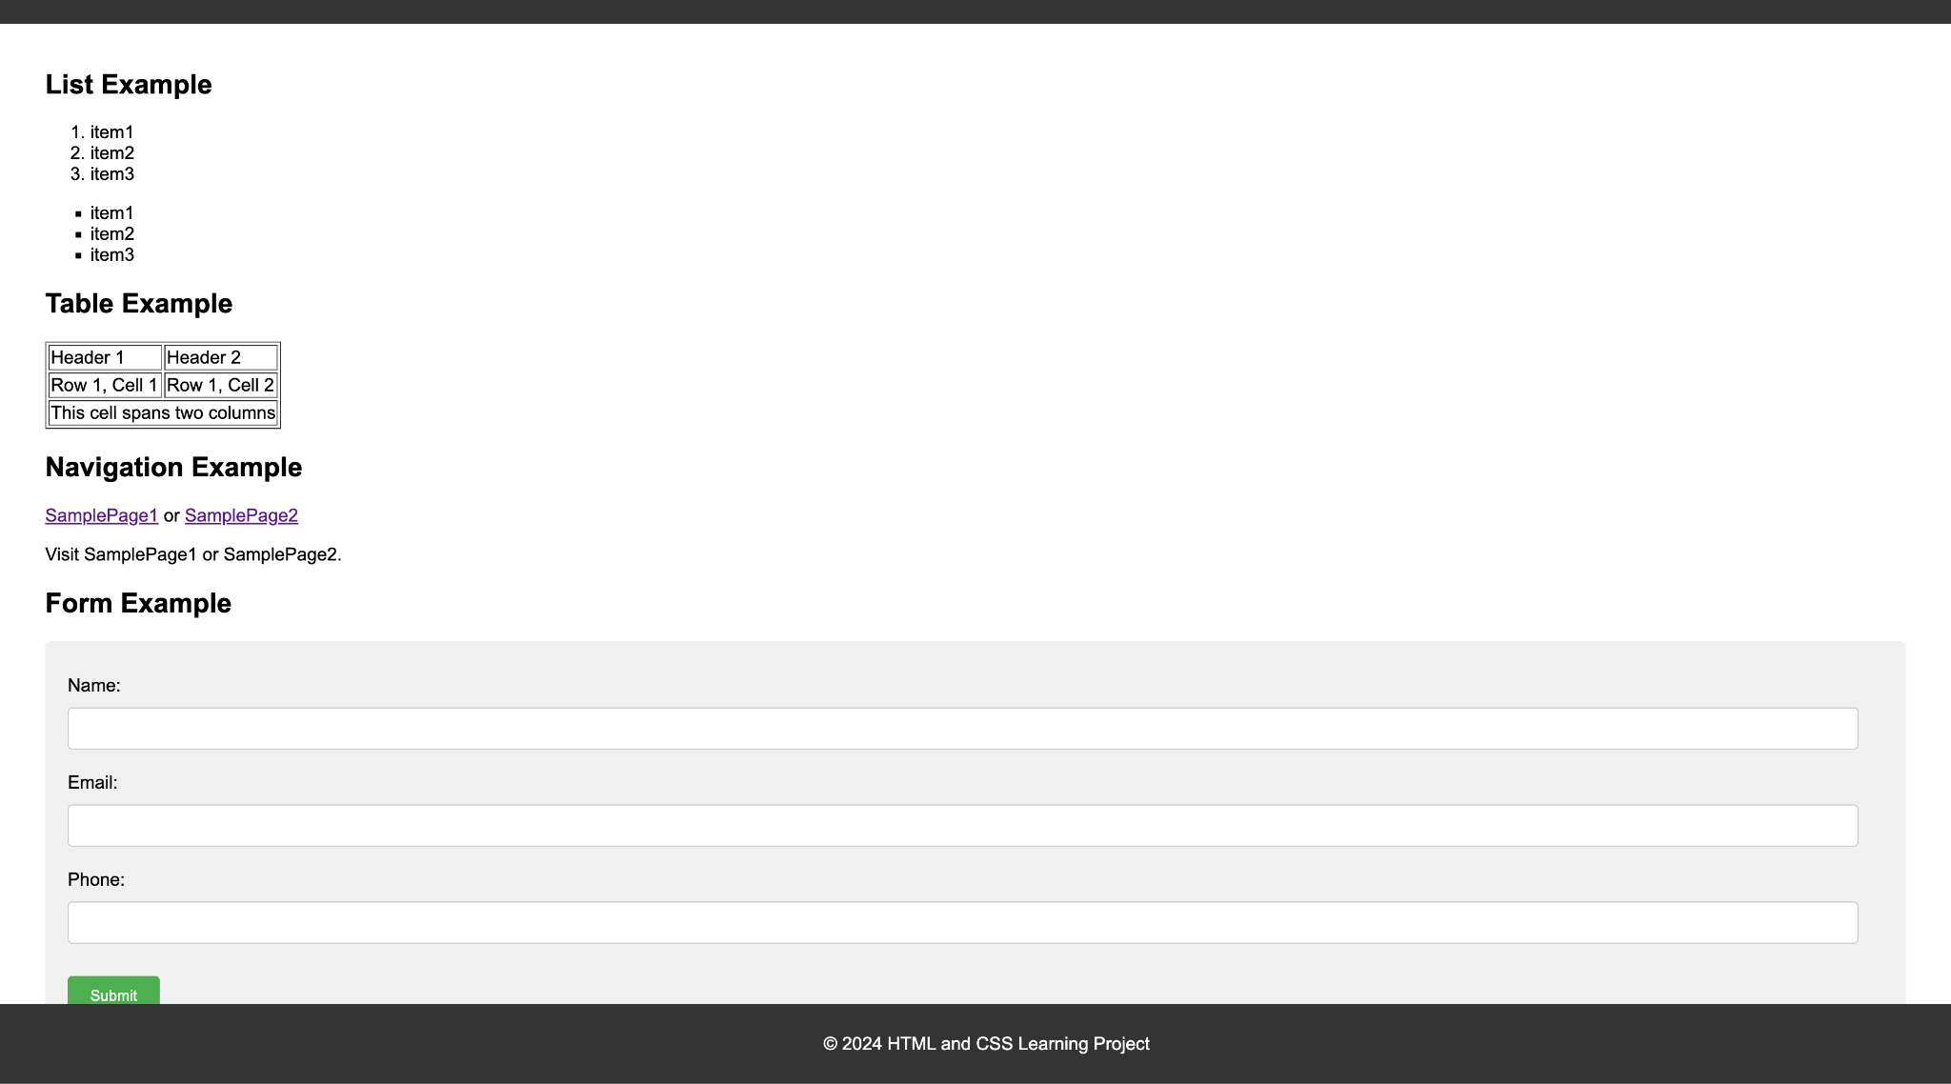

# Task 2

1. Use of git add command

* To stage the changes necessary for the next commit
* Tells git the files to include from the working directory into the next commit

1. Git branch command

* git branch “feature-group”
* Makes the branch pulling data from the existing working branch

1. Pull request

* Simple way to propose changes from one branch to another
* Steps:
  + Push your branch with new changes to git
  + Click compare and Pull request
  + Add meaningful title and description
  + Create pull request

1. Github repo -> Settings -> Add collaborators -> Add github username or email id -> Click add
2. Command to commit changes

* git commit -m “Msg to commit”

1. Github link : https: <https://github.com/mp1711/rg-assignments>
2. Created branch feature-java : <https://github.com/mp1711/rg-assignments/tree/feature-java>
3. SS of hello world project java in intellij

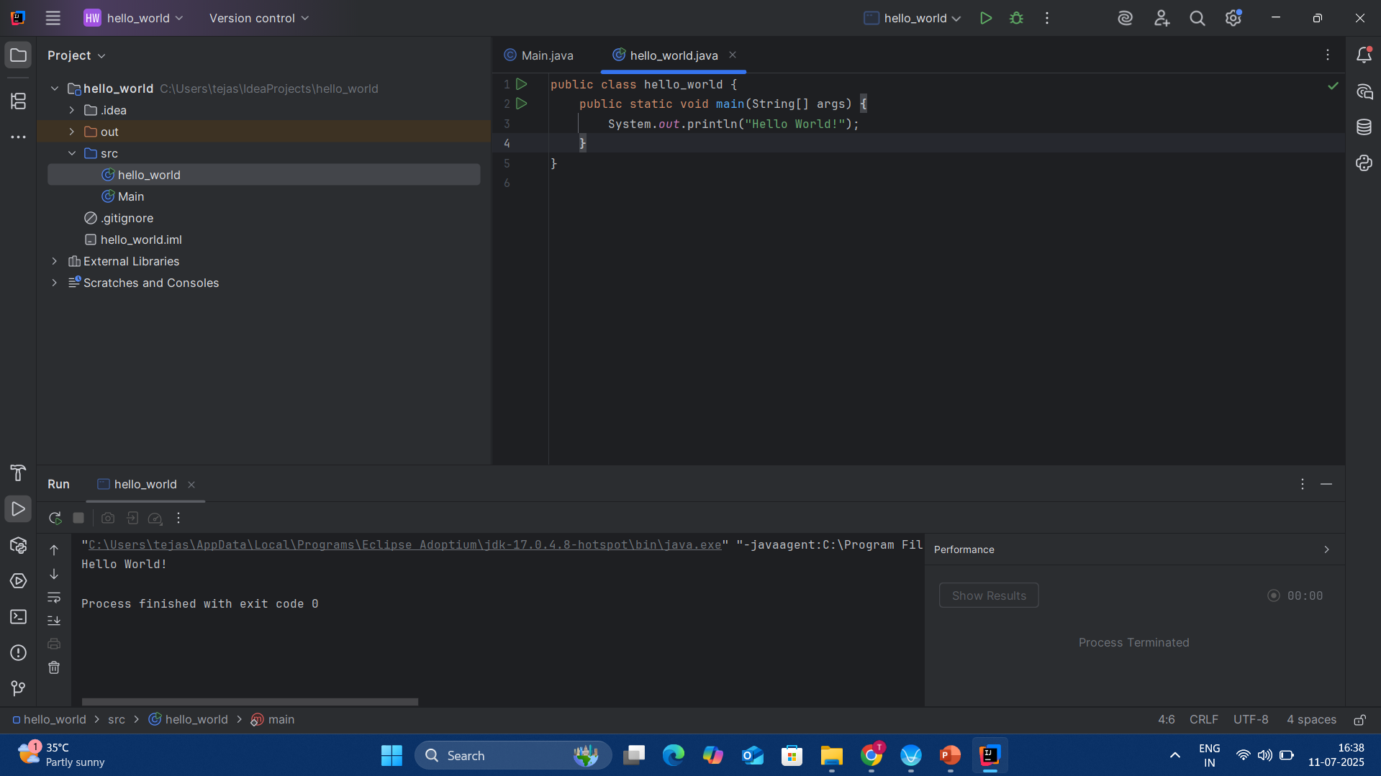

1. Shortcut keys exploration
   1. Run project - Command + F9
   2. Select a line - Shift + Command + right/left or triple click on the line
   3. Comment/Uncomment a lint - Command +[Option] + /
   4. To delete a line - Command + backspace